**Jifunz Data Engineering Bootcamp**

**SQL MINI PROJECT**

**By**

**Dotun Alex Omoboye**

**July 2022**

**Question 1:**

Provide the top 10 customers (full name) by revenue, the country they shipped to, the cities and their revenue (orderqty * unitprice).

**Query**

SELECT TOP 10

CONCAT(c.FirstName, ' ',c.MiddleName, ' ',c.LastName) AS FullName,

CONCAT(a.CountryRegion, ', ', a.City) AS Location,

SUM(sod.OrderQty * sod.UnitPrice) AS Revenue

FROM SalesLT.Customer c

JOIN SalesLT.SalesOrderHeader soh ON c.CustomerID = soh.CustomerID

JOIN SalesLT.CustomerAddress ca ON c.CustomerID = ca.CustomerID

JOIN SalesLT.Address a ON ca.AddressID = a.AddressID

JOIN SalesLT.SalesOrderDetail sod ON soh.SalesOrderID = sod.SalesOrderID

GROUP BY c.CustomerID, c.FirstName, c.MiddleName, c.LastName, a.CountryRegion, a.City

ORDER BY Revenue DESC

**Result**

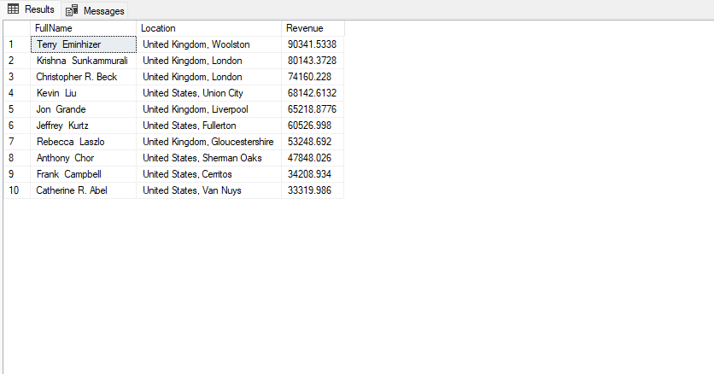

**Question 2:**

Create 4 distinct Customer segments using the total Revenue (orderqty * unitprice) by customer. List the customer details (ID, Company Name), Revenue, and the segment the customer belongs to.

**Query**

SELECT c.CustomerID , c.CompanyName, SUM(sod.OrderQty * sod.UnitPrice) AS Revenue,

CASE

WHEN SUM(sod.OrderQty * sod.UnitPrice) >= 70000 THEN 'Plantinum'

WHEN SUM(sod.OrderQty * sod.UnitPrice) >= 50000 THEN 'Gold'

WHEN SUM(sod.OrderQty * sod.UnitPrice) >= 30000 THEN 'Silver'

WHEN SUM(sod.OrderQty * sod.UnitPrice) < 30000 THEN 'Bronze'

END AS [Level]

FROM SalesLT.Customer c

JOIN SalesLT.SalesOrderHeader soh ON c.CustomerID = soh.CustomerID

JOIN SalesLT.SalesOrderDetail sod ON soh.SalesOrderID = sod.SalesOrderID

GROUP BY c.CustomerID, c.CompanyName

ORDER BY Revenue DESC;

**Result**

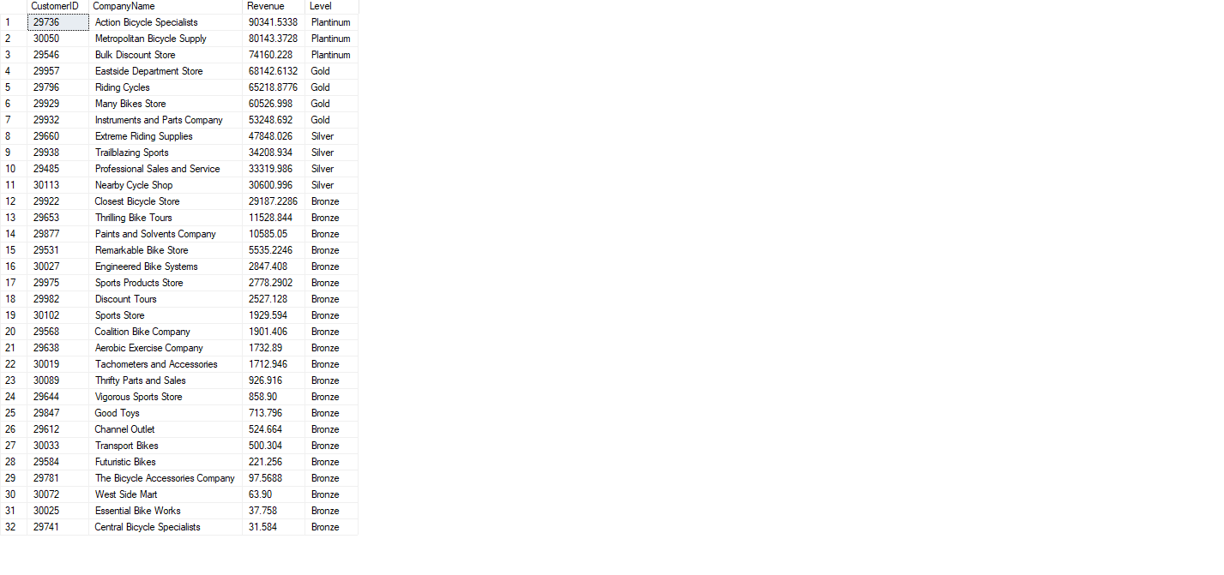

**Question 3:**

What products with their respective categories did our customers buy on our last day of business? List the CustomerID, Product ID, Product Name, Category Name, and Order Date.

**Query**

SELECT soh.CustomerID, sod.ProductID, p.Name AS ProductName, pc.Name AS CategoryName, soh.OrderDate

FROM SalesLT.SalesOrderHeader soh

JOIN SalesLT.SalesOrderDetail sod ON soh.SalesOrderID = sod.SalesOrderID

JOIN SalesLT.Product p ON sod.ProductID = p.ProductID

JOIN SalesLT.ProductCategory pc ON p.ProductCategoryID = pc.ProductCategoryID

WHERE soh.OrderDate = (SELECT MAX(OrderDate)

FROM SalesLT.SalesOrderHeader);

**Result**

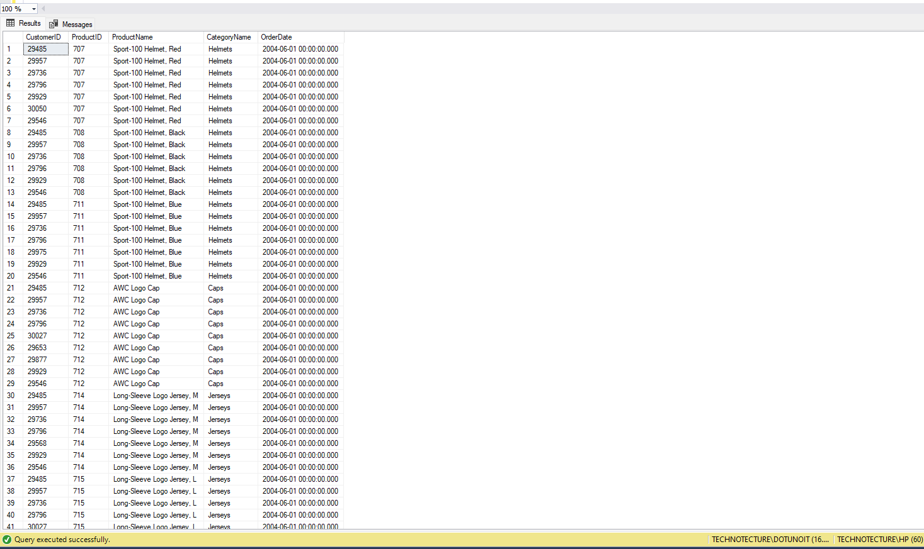

**Question 4:**

Create a View called customer segments that stores the details (id, name, revenue) for customers and their segment (from Question 2).

**Query**

SELECT c.CustomerID , c.CompanyName, SUM(sod.OrderQty * sod.UnitPrice) AS Revenue,

CASE

WHEN SUM(sod.OrderQty * sod.UnitPrice) >= 70000 THEN 'Plantinum'

WHEN SUM(sod.OrderQty * sod.UnitPrice) >= 50000 THEN 'Gold'

WHEN SUM(sod.OrderQty * sod.UnitPrice) >= 30000 THEN 'Silver'

WHEN SUM(sod.OrderQty * sod.UnitPrice) < 30000 THEN 'Bronze'

END AS [Level]

FROM SalesLT.Customer c

JOIN SalesLT.SalesOrderHeader soh ON c.CustomerID = soh.CustomerID

JOIN SalesLT.SalesOrderDetail sod ON soh.SalesOrderID = sod.SalesOrderID

GROUP BY c.CustomerID, c.CompanyName

ORDER BY Revenue DESC;

**Result**

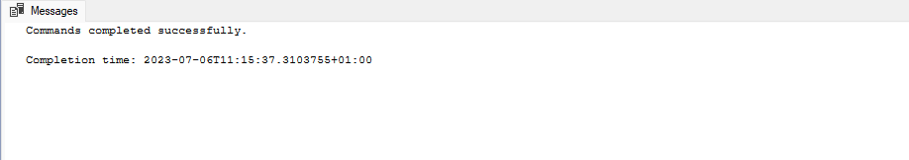

**Question 5:**

What are the top 3 selling products (include product name) in each category (include category name) by revenue? Tip: Use ranknum.

**Query**

SELECT CategoryName, ProductName, Revenue

FROM (

SELECT pc.Name AS CategoryName, p.Name AS ProductName,

SUM(sod.OrderQty * sod.UnitPrice) AS Revenue,

RANK() OVER (PARTITION BY pc.Name ORDER BY SUM(sod.OrderQty * sod.UnitPrice) DESC) AS RankNum

FROM SalesLT.SalesOrderDetail sod

JOIN SalesLT.Product p ON sod.ProductID = p.ProductID

JOIN SalesLT.ProductCategory pc ON p.ProductCategoryID = pc.ProductCategoryID

GROUP BY pc.Name, p.Name

) ranked

WHERE RankNum <= 3;

**Result**

